
NAME: ANGELA MANDE
SEX: FEMALE

AGE: 22
DATE: 15/12/2023

TEST RESULT

PREGNANCY TEST NON REACTIVE

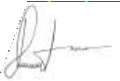

Med. Lab. Scientist. Sign/Date

